Feedback: 5 January

# | Screenshot | Comment
1 | N/A | Cancelling a plan  Please change the refund threshold to 48 hours instead of 72) – this is a changed requirement, not a bug.
2 | 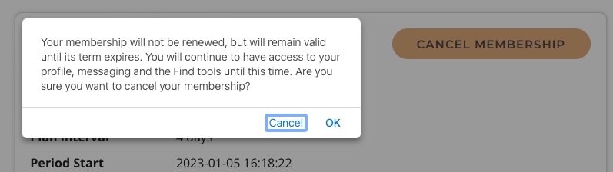 | Cancelling a plan (with refund)  When user cancels membership within the refund threshold they receive the same message as a user cancelling later. This is confusing, as they will be refunded and will no longer have access to the site. Can you create a different message for users who cancel within 48 hours?  This message should say  “Are you sure you wish to cancel your membership? If you proceed, your membership will be cancelled immediately and you will receive a full refund. The refund may take several days to display in your bank account.”
3 | N/A | Testing the automatic refund  Automatic refund cannot be tested. When I log in to Stripe to change the mode, it is already live. How can I test the automatic refund?
4 | Image 1  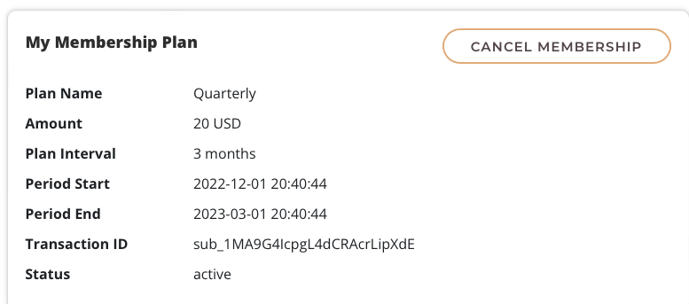  Image 2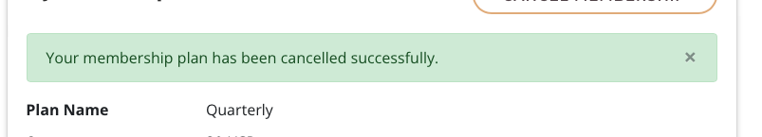 | Cancelling a plan (no refund)  When a user cancels their plan after the refund threshold has expired and logs back in, they still see the ‘cancel membership’ button (image 1). This should not occur – they have already cancelled.  There is a pop-up box (image 2) that appears only immediately after they have cancelled their membership, but not if they log in again. This should still display if they log in to show that they have already cancelled, and the cancel button should no longer display.
5 | 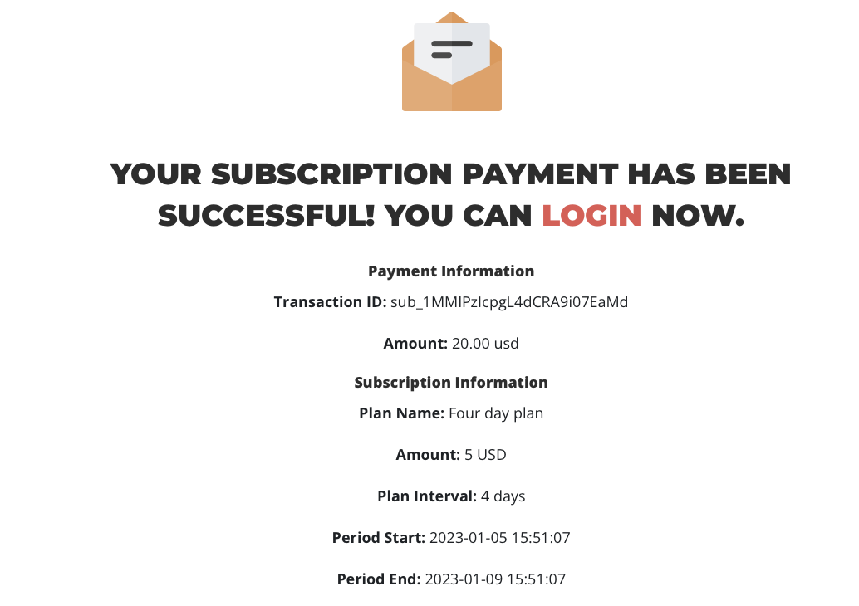 | Plan charges  Created a new four day plan expecting the amount to be $5. However, it was $20.  When creating a plan, the fee seems to be for the ‘interval’ chosen, not the plan duration. Is it possible to set the fee according to the plan duration?
6 | Image 1 – current build – default page load  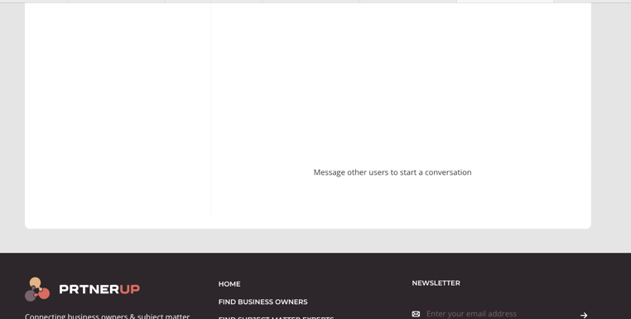 | Messages page  See image 1: the messages page loads at bottom of page – need to scroll up on desktop computer to see list of users in inbox.  Please make this page load at the top of the page.
7 | 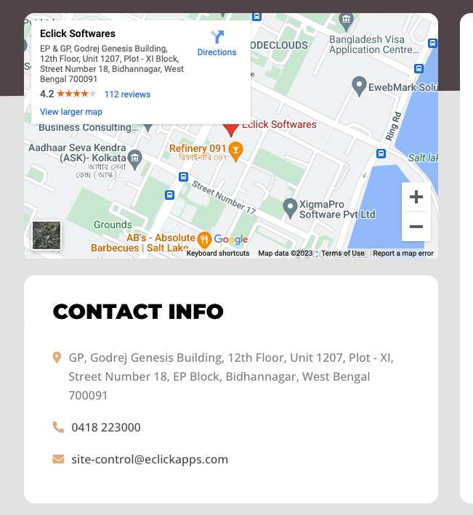  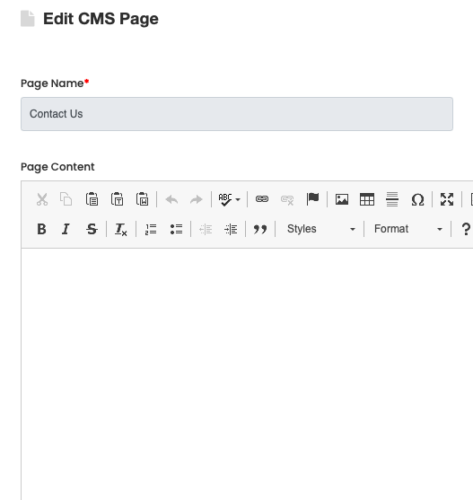 | Contact us page – edit details  Contact info cannot be edited in the admin page. There is no content to edit when the ‘contact us’ page is clicked.  How do I edit the contact details?
8 |  | Temporary landing page – email registration  Using the ‘register now’ button triggers an email to the user that the subscription was successful, but the email address does not appear in the newsletter database in the admin page.

